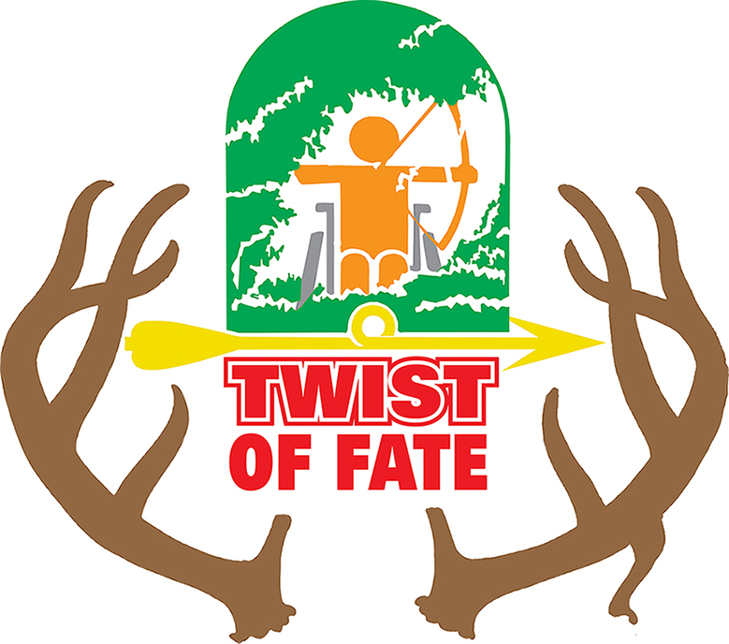
Physically Challenged Hunt
Questionnaire
Please fill out this questionnaire to the best of your ability.
Please be specific and return to us. Thank You!
Today’s Date_________________________
Name_____________________________________________________________________________
Address___________________________ City, State, Zip____________________________________
Phone__________________________ E-Mail____________________________________________
Birthday______________________ Height_________ Weight________ Eye Color___________
If you get selected to participate in the hunt we will need your social security number to get the deer license. We will only ask if you are chosen to participate.
Please describe your physical challenge_________________________________________________
_________________________________________________________________________________
_________________________________________________________________________________
Do you have any special needs we need to prepare for in the field? _________________________
________________________________________________________________________________
________________________________________________________________________________
Will you be using a crossbow or a compound bow? ______________
If you are using a crossbow, you will need a North Dakota Crossbow permit. This is a crossbow hunt, but you are welcome to use your own compound bow if you like.
Do you have a crossbow permit for North Dakota? ______________________
Do you have a Hunter’s Fire Arms Safety Number? _______________________________________
Our usual shooting distance is 20 yards are you comfortable with that. _____________________
Do you have any hunting experience? ________________________________________________
Will you be staying on site? _________________________
Are you bringing a companion? ____________________
Companions Name _______________________________ Phone number________________________
Do you need transportation from Fargo? ________________________
Do you have any special dietary needs? _________________________________________________
_________________________________________________________________________________
Do you have camouflage or other hunting clothing? _______________________________________
What is your jacket size? _____________________________________________________________
What is your shirt size? _______________________________________________________________
How far are you able to travel from the vehicle to the hunting spot? __________________________
Any other information you would like to share about yourself. _________________________________
___________________________________________________________________________________
___________________________________________________________________________________
___________________________________________________________________________________
How did you hear about Twist of Fate? ___________________________________________________
Please mail this form to
Twist of Fate
3605 5th ST South
Moorhead, MN 56560
Or email to
twistoffatend@gmail.com
Sending in this questionnaire does
not guarantee a spot in the
Twist of Fate Hunt
Twist of Fate is not a trophy hunt. Volunteers spend a lot of time getting permission from landowners, prepping the location for easy access and making sure the hunter has best opportunity of harvesting a deer.

